Account # _____________

Property Location: ____________________

City of Garner
Automatic Payment Agreement

Direct debit is a safe and secure way to have your City of Garner Utility Bill drafted directly from your checking or savings account. Direct debit is reliable, convenient and eliminates late fees. A Utility Bill will be mailed to you as usual on the 1st of the month with a printed reminder that your payment will be deducted from your bank account on the 15th or next business day.

I hereby authorize the City of Garner to direct debit the full balance of my City of Garner Utility Bill from the account and financial institution listed below on the 15th of each month or next business day. I understand that both the financial institution below and the City of Garner Utilities reserve the right to terminate this Payment Agreement upon mailing written notice to my last known address.

Bank Name: __________________________________________

Routing Number: __________________________________

Account Number: ______________________________________

Account type:

- Checking

- Savings

Resident or Property Owner: _______________________________
Printed Name

__________________________________ Date: ___/___/___
Signature

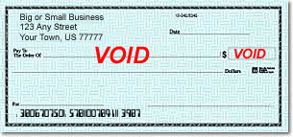
(Attach voided check here)

OFFICE USE: Date Received: _________________ Date Activated: _________________

